CHAPTER 9

ISSUE MANAGER

Contents:
- Overview
- Add a New Issue
- Modify an Issue
- Delete an Issue
- Add to the Knowledge Base
- Add or Delete Issue Conditions and Values
- Verify or View Service Contract Information
- Add, View, or Delete Attachments
- View and Add to Issue History
- Issue Work Groups
- Communicating with Work Group Members
- View Issues and Messages Sent to you by Work Group Members
- Use the Search Engine to Find an Issue
- Print SnapShot Report

Overview
The Issue Manager module is the heart of SDS HelpDesk. It is the module you use whenever you talk with a customer. When a customer contacts you for support, you log it in as an “issue.” An issue can be a how-to question, a broken piece of equipment, a leaky faucet, a software program bug, etc.
Issue Manager lets you categorize issues any way you want to. It then automates the collection of related information, and tracks the issue until it is resolved. Once resolved, you can add the final solution to the knowledge base so that others can use it.
The Issue Manager module lets you see and do a lot of things from one screen. You can:
- Record new issues and track the progress to their resolution.
- See a history of all events related to an issue including status changes, escalations, or changes in priority.
- Attach supporting files such as word processing documents, faxes, spreadsheets, CAD drawings, etc.
- Set up issue work groups. A work group exists solely for the purpose of resolving a single issue. The work group can include both internal members of your organization and experts outside your organization.
- Be notified of any issues that have been sent to you by other work group members for your input.
- Communicate with other work group members through the built-in messaging system.
- See immediately whether a customer’s service contract is valid. If you need to see the details, you can launch the Service Contract module directly from Issue Manager.
- Use the powerful search engine to quickly scan the knowledge base for solutions to repeat issues.
- Print a SnapShot report that summarizes key information for an issue.
Click the Issue Manager icon  in the toolbar to open the module.
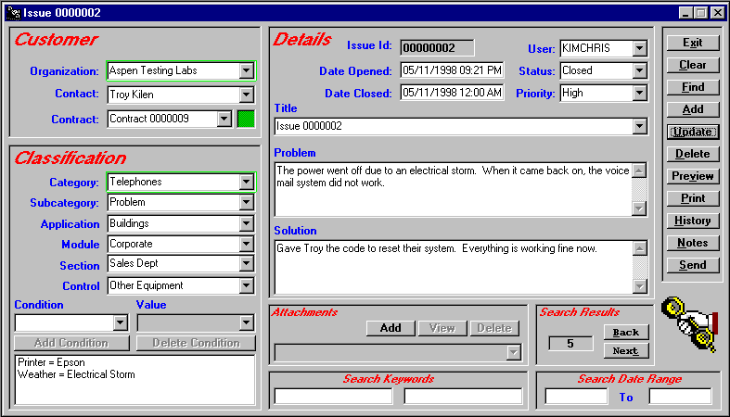
Your system administrator can change these four location labels to fit the needs of your company.

Issue Manager
NOTE: The green boxes around the Organization and Category fields indicate that these are mandatory fields and must be filled in for each issue.

 Steps to . . .

Add a New Issue
When a customer calls with a new issue, you want to be able to gather information quickly so you can begin to resolve the issue right away. SDS HelpDesk does not require very much information to enter a new issue. At a minimum, you need to enter a category, the organization, the user, and a description of the issue. However, the more information you can enter, the more useful Issue Manager will be to you.
The following steps assume you are adding all of the issue information at once.

Add a New Issue (cont’d)
- Select the organization name from the Organization drop down list, or click the Organization label to select from a PickList. Once selected, SDS HelpDesk automatically searches for the contacts at that organization and for associated service contracts. Select the name of the contact with an issue to report from the Customer drop down list.
- Check the Contracts portion of the screen (upper left hand corner) to see if the organization has a valid service contract. The box is green if the contract is valid, red if it is not. You will need to refer to your company policy on how to proceed if the organization does not have a valid service contract.
- Ask your customer for a description of the issue. Type a summary in the Problem box. The Problem and Solution boxes expand when you click in them. Click outside the box to return it to its normal size.
- Most issues can be grouped into general categories, such as product defect, how-to question, feature wish, warranty work, broken equipment, etc. These groupings give you a quick way to track and compare similar issues. Some issues can be broken down further into subcategories. For example, if you have a category called Broken Equipment, you might have multiple subcategories called Copy Machines, Plumbing, Personal Computers, Printers, etc. Click the Category label to open the PickList. A plus (+) next to a category means that it has one or more subcategories. Click the plus (+) to see the subcategory level. Select an appropriate category or subcategory. If you select a subcategory, it and the category it is associated with are entered for you automatically.
- Since this is a new issue, select Open from the Status drop down list.
- You can indicate this issue’s importance by selecting a priority from the Priority drop down list, or click the label to select from the PickList.
- The Date Opened field is filled in automatically for you when the issue is added.
- The last four drop down boxes are used to identify where an issue has occurred. Your system administrator should have changed these labels to fit your company’s needs. Used together, the drop down lists represent four location levels. As you go down each level, the location category gets more precise.

Add a New Issue (cont’d)
EXAMPLE 1: If you develop a product, the highest level might be Product Name. The next level could be Model Number. The third level might be Product Area (e.g., motor, screen), and the fourth level could be Part Number.
EXAMPLE 2: If you handle facilities' management for several apartments, your highest level might be Complex Name. The next level could be Building Number, level three could be Apartment Number, and level four, Item (e.g., bedroom window, bathroom plumbing).
Click any of the Location labels to open the PickList. A plus (+) next to a location means that it has one or more levels below it. Click the plus (+) to see the next level. Select an appropriate level from the tree and all of the higher levels are filled in for you automatically.
- You can also record various conditions that may have an influence on an issue. For example, manufacturing environments have different production lines, multiple labor shifts, and different tools or machinery. Like categories, each of these “conditions” can have multiple subcategories, called “values.” For the condition labor shifts, we can have multiple values such as Day, Evening, and Graveyard.
Select a condition and a value from the corresponding drop down lists, or click either label to select from the PickList. Click the plus (+) next to a condition to view its values. Select the Value and it and its associated Condition are entered for you automatically. Click the Condition Add button. The condition and its value are displayed in the Condition list box. You can add as many conditions and values as are appropriate for this issue.
- When you have finished adding the minimum information (organization, category, user, and issue description), and any other information that may be necessary for you to resolve the issue, click the Issue Manager Add button.
- When another customer calls and you need to enter a new issue, click the Clear button to give you a blank screen.

Modify an Issue
Once you enter an issue into SDS HelpDesk, your primary goal is to resolve it as quickly as possible. You may be able to offer a solution while the contact is still on the phone, or you may have to research the issue, or consult with another expert. Whatever the case, you will need to modify the issue record and document the solutions you suggest. You can also modify any previously entered information.
- Select the organization name from the Organization drop down list, or click the Organization label to select from a PickList.
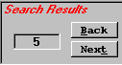
- Once the organization is selected, click the Find button. You will see a number in the lower right hand corner of the Issue Manager screen (that portion of the screen is recreated below). The number represents how many issues have been entered for this organization. The first issue in the list is displayed.

NOTE: You can also use the Next and Back buttons to scroll through the issues one-by-one.

- Modify or add any appropriate information for this issue.
- Type a description of your suggestion or solution into the Solution box. Include any information that you might find helpful. You can also use the Attachment function to include other relevant documents.
NOTE: The Solution and Problem boxes expand when you click in them. Click outside the box to return it to its normal size.
- If the solution resolves the issue, change the status to Closed. The Date Closed field is entered for you automatically when you save your changes.
- When you have finished adding your solution, or have modified any of the other issue information, click the Update button to save your changes.
- Click the Clear button to give you a blank screen.

Delete an Issue
In most cases, you will only delete an issue that you really don’t want. This may be an issue that has been duplicated by accident, or entered for the wrong organization.
- Select the organization name from the Organization drop down list, or click the Organization label to select from a PickList.
- Once the organization is selected, click the Find button. You will see a number in the lower right hand corner of the Issue Manager screen. The number represents how many issues have been entered for this organization.
- The first issue is displayed. Click the Title down arrow to see a list of all issues for this organization. Select the issue you want to delete.
NOTE: You can also use the Next and Back buttons to scroll through the issues one-by-one.
- Click the Delete button. Once you delete an issue, you will not be able to get it back.

Add to the Knowledge Base
The SDS HelpDesk knowledge base is used to store and retrieve answers to repeat questions. It can be used to maintain step-by-step instructions, scripts, system configuration information, part numbers, lists of tools and materials to do a job, and just about anything else desired.
You can preload the knowledge base with information, or build it up over time as issues are entered and resolved. Use the search engine to quickly scan the knowledge base for the solution or information you need.
The following are two ways to add information to the knowledge base:
Add to the Knowledge Base by Using a Resolved Issue as a Template
Knowledge base information should include only the final solution to a repeat problem, or precise instructions on how to do something. Rather than typing this information in from scratch, you can use a resolved issue as a template, modify it, and then add it to the knowledge base.
- Select a resolved issue with a final solution that could be useful to other users.
- Select the issue Title to highlight it. Press the Delete key on your keyboard.
- Modify the issue description and/or resolution to make it generic, and to include only the final solution.
- Change drop down box selections as needed (e.g., priority and status) so they are blank.
- Select Knowledge Base from the Organization drop down list, or click the label to select Knowledge Base from the PickList.
- Click the Add button. This does not change any of the information for the issue that you used as a template. It just lets you add the key portions of the issue to the knowledge base.
Add to the Knowledge Base Without Using a Template
The process for doing this is the same as adding a new issue. The only difference is that you select Knowledge Base from the Organization drop down list or PickList. The knowledge base information should include the final solution to a repeat problem, precise instructions on how to do something, or general information that can be useful to other users.
- Select Knowledge Base from the Organization drop down list, or click the label to select Knowledge Base from the PickList.
- Type a description of the issue in the Problem box.
NOTE: The Problem and Solution boxes expand when you click in them. Click outside the box to return it to its normal size.
- Select an issue category from the Category drop down list, or click the label to select from the PickList. If appropriate, also select a subcategory.
Add to the Knowledge Base Without Using a Template (cont’d)
- Leave the Status blank.
- You can leave Priority blank.
- The Date Opened field is filled in automatically for you when you add the issue.
- The last four drop down boxes are used to identify where a knowledge base issue has occurred. Your system administrator should have changed these labels to fit your company’s needs. Used together, the drop down lists represent four location levels. As you go down each level, the location category gets more precise.
EXAMPLE 1: If you develop a product, the highest level might be Product Name. The next level could be Model Number. The third level might be Product Area (e.g., motor, screen), and the fourth level could be Part Number.
- Click any of the Location labels to open the PickList. A plus (+) next to a location means that it has one or more levels below it. Click the plus (+) to see the next level. Select an appropriate level from the tree and all the higher levels are filled in for you automatically.
- You can also record various conditions that may have an influence on an issue. For example, personal computers have different operating systems, different amounts of memory (RAM), or be connected to different printers. Like categories, each of these “conditions” can have multiple subcategories, called “values.” For the condition operating system, we can have multiple values such as Windows 95, Windows 98, Windows NT, OS/2, etc.
- Select a condition and a value from the corresponding drop down lists, or click either label to select from the PickList. Click the plus (+) next to a condition to view its values. Select the Value and it and its associated Condition are entered for you automatically. Click the Condition Add button. The condition and its value are displayed in the Condition list box. You can add as many conditions and values as are appropriate for this resolved issue.
- When you have finished adding the appropriate knowledge base information, click the Issue Manager Add button.

Add or Delete Issue Conditions and Values
Different conditions can influence or even cause an issue. For example, temperature, humidity, and weather can affect certain pieces of equipment. Like categories, each of these “conditions” can have multiple subcategories, called “values.” If you choose the condition temperature, it can have multiple values such as normal, < 32 degrees F, or > 32 degrees F.
When you enter an issue, you can include the conditions and values that were in effect when the issue occurred. This helps you determine whether an issue occurs under all conditions or only under certain conditions.
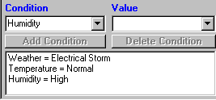

Add or Delete Issue Conditions and Values (cont’d)
- Select the issue where you want to add or delete Conditions.
- To add a condition to an existing issue, select the condition and a value from the corresponding drop down lists, or click either label to select from the PickList. Click the plus (+) next to the condition to see the values. Select a value, and then click the Add Condition button. The condition and its value are displayed in the Condition list box. You can add as many conditions and values as is appropriate for this issue.
To delete a condition from an issue, select the condition from the large list box. Then click the Delete Condition button.
- When you are finished adding or deleting conditions, click the Update button to save your changes.

Verify or View Service Contract Information
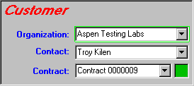
One of the first things you should do when a customer calls for support is verify whether the organization has a valid service contract. You can do this directly from the Issue Manager screen (that portion of the screen is recreated below for your reference).
This box is green for valid service contracts, and red for expired or nonexistent contracts.

- When a customer calls, select the organization name from the Organization drop down list, or click the label to select from the PickList.
- Check the Contracts portion of the Issue Manager screen (located in the upper left corner). If an organization only has one contract, it is displayed. If there are multiple contracts, the numbers are displayed in the drop down list. Select the appropriate contract.

Verify or View Service Contract Information (cont’d)
- When a service contract is valid, the small box is green. The box is red if the contract has expired or the organization does not have a contract.
NOTE: You will need to refer to your company policy on how to proceed with the customer if the service contract is no longer valid or a contract does not exist.
- If you need to see the details of a contract, click the Contract label to launch the Service Contract module. It takes you directly to the contract you selected. When you exit the Service Contract module you are returned to your place in Issue Manager.

Add, View, or Delete Attachments
You can attach supporting files such as word processing documents, spreadsheets, CAD drawings, faxes, etc. to any issue. SDS HelpDesk lets you add multiple supporting files and view them right from Issue Manager.
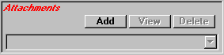

- Select the issue that you want to attach a supporting file to.
- Make sure the supporting file is in a directory you can access when you are in SDS HelpDesk. Some users create a subdirectory under Helpdesk and copy supporting files into it.
- Click the Attachments Add button. This opens the Locate Attachment dialog box.

Add, View, or Delete Attachments (cont’d)
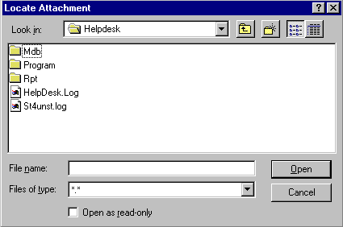Locate Attachment Dialog Box
- Use the Look In drop down list to find the folder where the file is located.
- Select the file you want to attach, then click the Open button. The full path to the file is displayed in the Attachments drop down box.
- Repeat the process for any additional supporting files you want to add.
- Click the Update button to save the attachments with the issue.
- You can click the View button to see a selected attachment.
- To delete an attachment, select it from the Attachment drop down list. Click the Delete button.
- Click the Update button to save your deletion.

View and Add to Issue History
Whenever you take action with an issue, you are adding to its history log. Some actions are added to the history automatically by SDS HelpDesk. These include when an issue is opened, who enters the issue, status changes, escalations to other work group members, and priority changes. You can add other information or comments manually that may be helpful.

- Make sure the appropriate issue is selected.
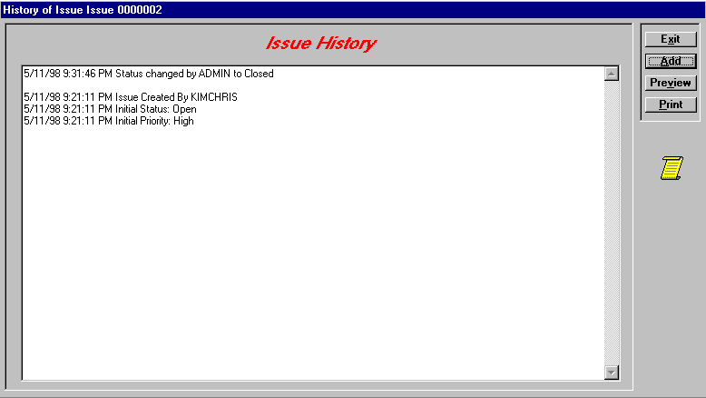
- Click the History button to open the Issue History dialog box. The major events that have taken place for this issue are displayed. Each event has a date and time stamp, and shows who created the event. Click the Print button to get a SnapShot Report of the history log.

- Click the Issue History Add button to open the Add to Issue History dialog box. This dialog box lets you add additional information to the history log. Click the Exit button to save the information and return to the Issue History dialog box.
NOTE: You must use the Add to Issue History dialog box to add information manually. This allows the program to date, time stamp, and record who created the entry.

Issue Work Groups
One of the problems in providing an effective support desk is finding the right people with the specific expertise needed to resolve issues. Some of these experts may be in other areas of your own organization. Others may be outside your organization.
SDS HelpDesk lets you form an issue work group. The work group exists solely for the purpose of resolving a single issue. Any internal or external contact can be added to an issue work group. You can select work group members by skill or contact type. You can send an issue to work group members so they can review it and make suggestions. Work group members can communicate with each other by using the built-in messaging system. SDS HelpDesk immediately alerts work group members when an issue is sent to them.
NOTE: Contacts must be designated as SDS HelpDesk users before they can be added to a work group.
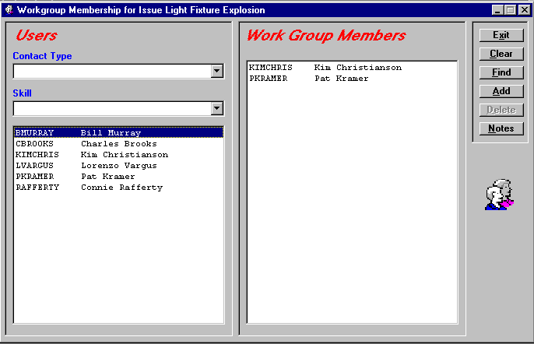
- Select the issue you want to set up the work group for. Click the Send button to open the Issue Work Group dialog box.
Work Group Dialog Box

Issue Work Groups (Cont’d)
When you set up your contacts in Address Book, you grouped them by contact type. You also assigned skills or levels of expertise for some of them. Use these two filters to help you identify which people have the skills needed to resolve the issue.
- Use the Contact Type drop down list to select a particular group of users. For example, you may have set up contact types called Outside Contractors, Plumbers, Employees, Vendors, etc. Once you select the contact type, click the Find button. The users who belong to that group are listed in the left-hand box.
- Use the Skill drop down list to select a particular skill or expertise that is needed to resolve the issue. Once you select the Skill, click the Find button. The users who have been assigned that skill will be listed in the left-hand box.
NOTE: You can use the Contact Type and Skill drop down lists either separately or together. When used together, the search engine looks for contacts who are part of the Contact Type group and have the selected skill. Select the Contact Type and Skill you want, and then click the Find button.
- Select the name of the user you want to add to the Issue Work Group. Click the Add button. The contact is listed in the right hand box. You can repeat this and the above steps as many times as you need to add other users to the work group.
- To delete a user from the Issue Work Group, select the name from the right hand list box. Click the Delete button. This only deletes the user from the work group, not from the Address Book.
- Use the messaging system to send a note to work group members along with the issue (see Communicating with Work Group Members). Click the Exit button to close the dialog box and send the issue and any attached message to work group members.

Communicating with Work Group Members
When you send an issue to work group members, you want to include some message that tells them what you would like them to do. Work group members then need some way of communicating their ideas or actions back to you. The SDS HelpDesk messaging system lets you use the Issue Notes as a forum for discussion among work group members. The Issue Notes screen also logs all work group communications.
There are two ways to add and send messages to work group members. You can send the issue and the attached message at the same time (this is usually done when the issue is first sent to work group members for review), or you can view the Issue Notes log and add a new message to it.
Send the Issue and the Attached Message at the Same Time
- Select the issue you want to send to work group members with an attached message.
- Click the Send button to open the Issue Work Group dialog box. If you have not set up your issue work group, you need to do it now (see Issue Work Groups).
- Click the Notes button to open the Work Group Notes dialog box. The box displays any previous notes that have been sent between work group members.
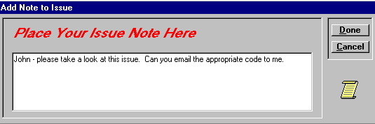
- Click the Add button to open the Add Notes to Issue dialog box.
- Type your message in the box. Be sure to check your message before exiting. Once you exit, you cannot edit the message.
Send the Issue and the Attached Message at the Same Time (cont’d)
- Click the Done button. Your message is logged into the Issue Notes, and it and the issue are sent immediately to the work group members. Members are alerted that an issue has been sent to them.
- Click the Print button to get a printout of the Issue Notes log. Click the Notes Exit button, and then click the Work Group Exit button.
View the Work Group Notes Log and Add a New Message To It
Once an issue is sent to work group members, the members need to communicate with each other about how to resolve it. The messaging system can be used as a forum for discussion, as well as a log of all communications sent between work group members.
- Select the issue you want to add a message to.
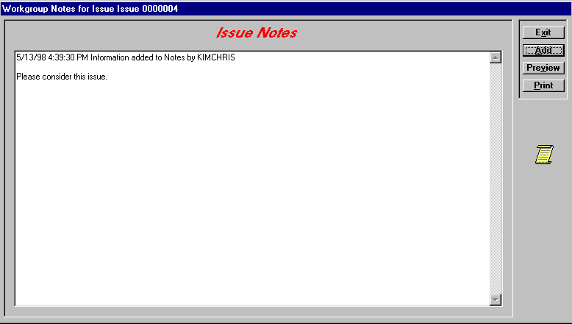
- Click the Notes button to open the Work Group Notes dialog box. The Notes screen displays a log of all work group communications.
- Click the Add button to open the Add Note to Issue dialog box.
NOTE: You must use the Add Note to Issue dialog box to add information manually. This allows the program to date, time stamp, and record who created the entry.
View the Work Group Notes Log and Add a New Message To It (cont’d)
- Type your message in the box. Be sure to check your message before exiting. Once you exit, you cannot edit the message.
- Click the Done button. Your message is logged into Issue Notes and sent immediately to the work group members. Members are alerted that they have a new message. Click the Print button for a printout of the Issue Notes log.
- Click the Issue Notes Exit button.

View Issues and Messages Sent to you by Work Group Members
When an issue or message is sent to you, you need to know right away so that you can take whatever action is necessary. SDS HelpDesk uses an unobtrusive, yet continually visible, messaging system that alerts you immediately when an issue or message is sent to you.
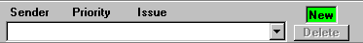
This portion of the messaging system is located in the upper right corner of the main SDS HelpDesk window.
This box turns green and displays “New” when a new issue or message is sent to you for review.

- Click the down arrow to see a list of the issues that have been sent to you by other work group members.
- Select the issue you want to review. SDS HelpDesk launches the Issue Manager module and displays the issue.
- Click the Notes button to see any attached messages. Add you own message or close the Issue Memorandum log.
- The small box in the right corner turns green and displays “New” when a new issue or message is sent to you. It stays this way until you review all of your work group issues.
- When you have finished providing your input or action on an issue, you can delete it from your drop down list. Select the issue from the drop down list, then click the Delete button. This only removes the issue from your list, not other work group member lists, or from Issue Manager.

Use the Search Engine to Find an Issue
SDS HelpDesk has a powerful search engine that can quickly scan the database. Search criteria can be as broad or narrow as desired. You can search using category, location, condition, status, priority, organization name, keywords, dates, or users.

The Search Engine supports “wildcards” so that it is possible to enter just a few letters of a criterion in order to find possible matches. A question mark (?) stands for any single character and an asterisk (*) stands for a number of characters. Wildcards can be placed before, after, or in the middle of other characters.
In the following examples a single criterion at a time is used for searching. Please keep in mind that you may narrow the amount of search results by using multiple search criteria at the same time.
The Knowledge Base
The program database has been preloaded with an organization called “Knowledge Base.” When desiring to preload all sorts of useful data that can later be queried, we suggest that you create issues and use as an organization name the pre-created name “Knowledge Base.” The information can be categorized and then placed in the problem and solution fields under this name so that it will be easy to access later.
Information you may wish to preload includes procedures, work arounds, bug fixes, lists of tools and materials needed to do a job, specifications, tables of information, and anything else you can think of.
Searching for Issues
After several issues are entered and resolved you will have a database that can be used by other support professionals to find answers to similar problems. The Search Engine provides many useful techniques for finding previous issues that may be useful in resolving a current problem.
NOTE: If you have a new issue open, you can launch another Issue Manager module to conduct your search of past issues. You can then copy and paste the appropriate resolution into the current issue.
Searching for Issues (cont’d)
Search by Issue Number
- Click the Clear button to give you a blank Issue Manager screen.
- Enter a number in the Number data entry box.
- Click the Find button.
Search by Organization
When a customer calls it is easy to find their issues by just doing a search on their company name.
- Click the Clear button to give you a blank Issue Manager Screen.
- Enter all or a portion of the organization name in the Organization data entry box. Use an asterisk before or after the name to represent the portion you didn’t include (e.g., *West, Scott*, *soft*).
- Click the Find button. When multiple records are found, press the Next button (lower right-hand corner) to sequence through the records.
Search by Organization Using the PickList
- Click the Clear button to give you a blank Issue Manager screen.
- Click the Organization label. A PickList of Organizations will appear. Double-click the organization you want. The PickList will close.
- The first contact at the selected organization is displayed. You can search on that contact, select a different contact by selecting the name from the Contact drop down list, or search only on the company. To search on the company, select the contact, and then press the delete key.
- Click the Find button. When multiple records are found, press the Next button (lower right-hand corner) to sequence through the records.
Searching for Issues (cont’d)
Search by Organization Using the Drop Down List
- Click the Clear button to give you a blank Issue Manager screen.
- Click the Organization drop down arrow to see a list of organizations. Select the organization you want.
- The first contact at the selected organization is displayed. You can search on that contact, select a different contact by selecting the name from the Contact drop down list, or search only on the company. To search on the company, select the contact, and then press the delete key.
- Click the Find button. When multiple records are found, press the Next button (lower right-hand corner) to sequence through the records.
Search by Organization Using Lookup Tables
- Click the Clear button to give you a blank Issue Manager screen.
- Right-click on the Organization label. A Lookup Table of Organizations will appear. Double-click the organization you want. The Lookup Table will close.
- The first contact at the selected organization is displayed. You can search on that contact, select a different contact by selecting the name from the Contact drop down list, or search only on the company. To search on the company, select the contact, and then press the delete key.
- Click the Find button. When multiple records are found, press the Next button (lower right-hand corner) to sequence through the records.
Search by Category Using the PickList
- Click the Clear button to give you a blank Issue Manager screen.
- Click the Category label. A PickList of Categories will appear. A plus (+) next to a category means that it has one or more subcategories. Click the plus (+) to see the subcategory level. Double-click the category or subcategory you want. The PickList will close.
- Click the Find button. When multiple records are found, press the Next button (lower right-hand corner) to sequence through the records.
Searching for Issues (cont’d)
Search by Category Using the Drop Down Lists
- Click the Clear button to give you a blank Issue Manager screen.
- Click the Category drop down arrow to see a list of categories. Select the category you want.
- Click the Subcategory drop down arrow. Select the subcategory you want.
- Click the Find button. When multiple records are found, press the Next button (lower right-hand corner) to sequence through the records.
Search by Category Using Lookup Tables
- Click the Clear button to give you a blank Issue Manager screen.
- Right-click either on the Category or Subcategory labels. A Lookup Table of Categories will appear. A plus (+) next to a category means that it has one or more subcategories. Click the plus (+) to see the subcategory level. Double-click the category or subcategory you want. The Lookup Table will close.
- Click the Find button. When multiple records are found, press the Next button (lower right-hand corner) to sequence through the records.
Search by Location Using the PickList
- Click the Clear button to give you a blank Issue Manager screen.
- Click any of the Location labels. A PickList of Locations will appear. A plus (+) next to a Location means that it has one or more levels below it. Click the plus (+) to see the next level. Double-click the level you want and all of the higher levels are filled in for you automatically. The PickList will close.
- Click the Find button. When multiple records are found, press the Next button (lower right-hand corner) to sequence through the records.
Searching for Issues (cont’d)
Search by Location Using the Drop Down Lists
The Location boxes are used to identify where an issue has occurred. Used together, the drop down lists represent four location levels. As you go down each level, the location category gets more precise. The more location levels you specify, the more specific your search results will be.
- Click the Clear button to give you a blank Issue Manager screen.
- Click the Location1 drop down arrow to see a list of locations. Select the highest location level you want.
- Click the Location2 drop down arrow. A list of sublocations will appear. Select the sublocation you want.
- Click the Location3 drop down arrow. A list of sublocations will appear. Select the sublocation you want.
- Click the Location4 drop down arrow. A list of sublocations will appear. Select the sublocation you want.
- Click the Find button. When multiple records are found, press the Next button (lower right-hand corner) to sequence through the records.
Search by Location Using Lookup Tables
- Click the Clear button to give you a blank Issue Manager screen.
- Right-click on any of the Location labels. A Lookup Table of Locations will appear. A plus (+) next to a Location means that it has one or more levels below it. Click the plus (+) to see the next level. Double-click the level you want and all of the higher levels are filled in for you automatically. The Lookup Table will close.
- Click the Find button. When multiple records are found, press the Next button (lower right-hand corner) to sequence through the records.
Searching for Issues (cont’d)
Search by Condition Using the PickList
- Click the Clear button to give you a blank Issue Manager screen.
- Click the Condition label. A PickList of Conditions will appear. A plus (+) next to a Condition means that it has one or more values associated with it. Click the plus (+) to see the value. Double-click the value you want and it and its associated condition are entered for you automatically. The PickList will close.
- Click the Find button. When multiple records are found, press the Next button (lower right-hand corner) to sequence through the records.
Search by Condition Using the Drop Down List
- Click the Clear button to give you a blank Issue Manager screen.
- Click the Condition drop down arrow to see a list of conditions. Select the condition you want. The selection list will close.
- Click the Value drop down arrow. An associated selection list will appear. Select the value you want. The selection list will close.
- Click the Add Condition button. Repeat the above process if you want to add another condition. If you set multiple condition/value criteria, the Search Engine will look for records that match all of the conditions you choose.
- Click the Find button. When multiple records are found, press the Next button (lower right-hand corner) to sequence through the records.
Searching for Issues (cont’d)
Search by Condition Using Lookup Tables
- Click the Clear button to give you a blank Issue Manager screen.
- Right-click on the Condition label. A Lookup Table of Conditions will appear. A plus (+) next to a Condition means that it has one or more values associated with it. Click the plus (+) to see the values. Double-click the value you want and it and its associated condition are filled in for you automatically. The Lookup Table will close.
- Click the Find button. When multiple records are found, press the Next button (lower right-hand corner) to sequence through the records.
Search by User Using the PickList
- Click the Clear button to give you a blank Issue Manager screen.
- Click the User label. A PickList of Users will appear. Double-click the User you want. The PickList will close.
- Click the Find button. When multiple records are found, press the Next button (lower right-hand corner) to sequence through the records.
Search by User Using the Drop Down List
- Click the Clear button to give you a blank Issue Manager screen.
- Click the User drop down arrow to see a selection list. Select the User you want. The selection list will close.
- Click the Find button. When multiple records are found, press the Next button (lower right-hand corner) to sequence through the records
Search by Status Using the PickList
- Click the Clear button to give you a blank Issue Manager screen.
- Click the Status label. A PickList of Statuses will appear. Double-click the status you want. The PickList will close.
- Click the Find button. When multiple records are found, press the Next button (lower right-hand corner) to sequence through the records.
Searching for Issues (cont’d)
Search by Status Using the Drop Down List
- Click the Clear button to give you a blank Issue Manager screen.
- Click the Status drop down arrow to see a selection list. Select the status you want. The selection list will close.
- Click the Find button. When multiple records are found, press the Next button (lower right-hand corner) to sequence through the records
Search by Status Using Lookup Tables
- Click the Clear button to give you a blank Issue Manager screen.
- Right-click on the Status label. A Lookup Table of Statuses will appear. Double-click the status you want. The Lookup Table will close.
- Click the Find button. When multiple records are found, press the Next button (lower right-hand corner) to sequence through the records.
Search by Priority Using the PickList
- Click the Clear button to give you a blank Issue Manager screen.
- Click the Priority label. A PickList of priorities will appear. Double-click the priority you want. The PickList will close.
- Click the Find button. When multiple records are found, press the Next button (lower right-hand corner) to sequence through the records.
Search by Priority Using the Drop Down List
- Click the Clear button to give you a blank Issue Manager screen.
- Click the Priority drop down arrow to see a selection list. Select the priority you want. The selection list will close.
- Click the Find button. When multiple records are found, press the Next button (lower right-hand corner) to sequence through the records
Search by Priority Using Lookup Tables
- Click the Clear button to give you a blank Issue Manager screen.
- Right-click on the Priority label. A Lookup Table of Priorities will appear. Double-click the priority you want. The Lookup Table will close.
- Click the Find button. When multiple records are found, press the Next button (lower right-hand corner) to sequence through the records.
Search for Issues Using Keywords and/or Dates
Keywords or dates can be used to search the database. The more specific the keywords are to your particular issue, the better the search results. For example, use the keyword phrase “open error 21” rather than just “error,” or use a specific part number such as “B452” rather than “sink.” Click the Find button to begin the keyword search.

You can also search by a specific date or date range. The date represents the issue open date.
- Enter a date (e.g., 1/1/97) only in the first date box. Click the Find button. The search locates all issues that were opened on this date.
- OR -
- Enter a date (e.g., 12/31/96) in the second date box. Click the Find button. The search locates all issues that were opened from the beginning of the database through this date.
- OR -
- Enter a range of dates (e.g., 1/1/97 to 12/31/97). Click the Find button. The search locates all issues that were opened between these two dates.
NOTE: You can also use the Date Opened and/or Date Closed fields to set search criteria. Just type the date into one or both fields and then click the Find button. This searches for a specific date rather than a date range.
Print SnapShot Report
You may want to print out information for a particular issue. You can do this directly from Issue Manager.
- Select the issue.
- Click the Preview button to see the report before it is printed.
- Click the Print button to get a SnapShot Report for this issue.

